HUMANITIES INSTITUTE
Jason Zimmerman, MA

Notorious (1946)
Alfred Hitchcock

Contents (Overview-Synopsis-Characters-Character Analysis-Themes-Scenes)
OVERVIEW
Director Sir Alfred Hitchcock (1899-1980) is a household name and perhaps the best-known British filmmaker. With over 50 films to his credit, Hitchcock helped to shape the modern understanding of the thriller genre. His best-known films include The Birds, Psycho, Vertigo, and Rear Window, all of which have earned accolades, including preservation by the US Film Registry. In 1960, Hitchcock was inducted into the Hollywood Walk of Fame with two stars for his work in both film and television. He was also the first recipient of the BAFTA Academy Fellowship Award.
Film Notorious is a loose adaptation of John Taintor Foote’s The Song of the Dragon, a short story released as a serial in 1921. The script was written by Ben Hecht just after his completion of the script for Spellbound. Over three weeks, Hecht and Hitchcock sat in conference to create the final script, Hecht writing but deferring heavily to Hitchcock’s vision. Notorious is a notable turning point for the director: After years under the stifling influence of David O. Selznick, Alfred Hitchcock became his own producer. Many of Hitchcock’s films, which still earn rankings among the greatest films of all time, were made after Notorious.
Background Notorious was a box-office success, generating $4.85 million in the US and Canada, and $7.15 million worldwide. Many modern critics still rate this film among Hitchcock’s greatest. Notorious is one of three Hitchcock films on Metacritic’s list of films with perfect 100 scores, the other two being Vertigo and Rear Window. The film premiered in Radio City Music Hall in New York City with a star-studded audience that included Carry Grant and Ingrid Bergman seated alongside Hitchcock. There have been many adaptations and homages to Notorious including Mission: Impossible 2 and a two-part episode of the television show Star Wars: The Clone Wars.
CINEMATIC NARRATION
Many modern viewers may find this film dated. The dialogue is ponderous at times, most of the plot is composed of MacGuffins, and the ending feels rushed. Notorious is very much a product of its time in these ways. The cinematography, however, is the most Hitchcockian of any of the films he’d made up to this point. His trademark voyeur stylings are so skillful that the inattentive won’t notice the expertly manned camera coasting behind or beside the film’s stars while they climb up stairs and cross rooms. Hitchcock uses many camera tricks we’ve seen before in Suspicion and The Lady Vanishes and introduces a few new ones that will come up in Vertigo and North by Northwest. Without a doubt, 1946 was the year that Hitchcock came into his own as a director and began his journey to becoming a household name.
SYNOPSIS
Alicia Huberman, the daughter of a convicted Nazi spy, is recruited by government agent T. R. Devlin to infiltrate a group of Nazi industrialists operating in Brazil. Initially resistant, Devlin convinces Alicia to assist by playing recordings of her expressing her love for America during a fight with her father. Their relationship takes a romantic turn, complicated by Devlin's knowledge of Alicia’s past. When tasked with seducing Alexander Sebastian, one of her father's friends and a prominent Nazi in Brazil, Devlin struggles to convince his superiors of Alicia's suitability for the mission. As the plan unfolds, Alicia marries Sebastian but secretly collaborates with Devlin to uncover the Nazis' activities. Devlin's true feelings for her emerge, and they work together to expose Sebastian's treachery. Their discovery of uranium ore in Sebastian's wine cellar sets off a chain of events that endangers Alicia's life. Alicia is poisoned by Sebastian and his mother for her suspected role in discovering the uranium, and Devlin rescues her, leaving Sebastian to face the wrath of his fellow conspirators..
MAIN CHARACTERS
T. R. Devlin—A U.S. government agent who falls in love with Alicia after recruiting her
Alicia Huberman—The daughter of a German war criminal
Alexander Sebastian—one of those Nazis, who had previously been infatuated with Alicia
Madame Anna Sebastian—Alexander’s mother and co-conspirator
Captain Paul Prescott—an officer of the US Secret Service operating in Rio De Janeiro
Dr. Anderson—a Nazi in Brazil
Eric Mathis—a Nazi in Brazil
Joseph—Sebastian’s butler
CHARACTER ANALYSIS
Alicia Huberman
Alicia is the daughter of a Nazi convicted in Miami of war crimes. After the trial, she leaves Miami with Devlin after being offered a chance to put some of her father’s comrades in jail. To further her role as an informant, she marries Alexander Sebastian.
Stubborn Alicia is incredibly hard-headed like many of Hitchcock’s leading ladies. She knows what she wants or has to do, and she does everything she can to make sure it happens. She is adamant that she drive at the film’s beginning despite her drunken state, further insisting that Devlin accompany her. She’s also incredibly hard-headed in her interactions with the policeman who pulls her over for drunken driving, insulting him and making things worse because he’s ruining her fun. Her stubbornness takes the sideline when she has to seduce Sebastian, but we see glimpses of it in her interactions with Devlin throughout the film. She often expresses her stubbornness through anger, trying to persuade Devlin that she still loves him but facing rejection and snide comments for doing the job he asked her to do. Even in her weakened state after being poisoned, Alicia practically pushes Devlin away, begging him to leave her and escape.
Attentive We see through Alicia’s eyes throughout the film, and Hitchcock’s skillful direction shows us just how attentive she is. She remembers every face she sees and tiny details of their dress, objects in the room, and how people act when they think they’re not being watched. Because she’s so attentive, she’s able to single out which areas of the house Sebastian keeps under lock and key, zeroing in on the wine cellar as a place to investigate. She notices during the party that the house staff is running out of champagne and the window for her and Devlin to look around the cellar is becoming smaller and smaller. Alicia is also the one to notice Sebastian and his butler descending the stairs, warning Devlin, who quickly covers for them by pulling her into a kiss in the garden. It doesn’t take long for Alicia to connect her sudden illness with the coffee Madame Sebastian gives her, but by then it’s too late. Even in her weakened state, she still reports on Sebastian’s activities for Devlin when he appears to rescue her at the film’s end.
Moody Alicia is prone to moods. We see her grief-stricken in the film’s first scenes, unable to come to terms with her father’s crimes without copious amounts of drink. In the very next scene, we see her taken by several moods. Despite her inebriation, she demands to drive and does so recklessly, showing how little she values her own life in her current state. Another mood takes her when Devlin seems unshaken by her unsafe driving. Spitefully, she pushes the car to its limits in an attempt to scare him. We see Alicia’s mood change once more after the trip to Brazil: she’s falling head-over-heels for Devlin and her attitude changes completely. She does another 180 when Devlin returns to her apartment with her assignment. Learning that she and Devlin can’t be together turns her spiteful once more. This spite remains between them throughout the rest of the film, but in spite of their conflict, they continue working well together. Even in her moody states, Alicia is able to keep her cover and work towards exposing Sebastian and his ring of co-conspirators.
T. R. Devlin
Devlin is a US Secret Service agent assigned to the foreign branch. He recruits Alicia in Miami for her father’s connections to other Nazis hiding in Brazil. Over the course of his mission, he falls in love with Alicia.
Confident Perhaps it’s just Carry Grant’s acting style, but Devlin oozes a subtle confidence. From his first moments on screen to the film’s conclusion, the US agent seems practically unshakable. The only time we see his confidence slip is when he realizes that Alicia will have to seduce Sebastian. In every other situation, he is primed and ready to take advantage of Sebastian’s weaknesses or the cracks in his security. There’s a swagger about him that helps Sebastian misplace his dislike of the man, assuming Devlin is only in contact with Alicia because he is in love with her. He plays on this, confidently forcing a kiss onto Alicia in the garden to cover for their activities in the wine cellar. We see his confidence also win the day when he forces Sebastian and his mother to escort Alicia to Devlin’s car. Devlin’s final words are spoken with steadfast confidence: “No room, Sebastian.” Devlin’s confidence in just about any situation makes him an excellent spy.
Spiteful Despite some of his more positive traits, Devlin has a mean streak when it comes to Alicia. This behavior does come from a place of love, though jealousy and professional distance warp his love into harshness. He dislikes her reliance on alcohol and constantly mocks her for it, even when her behavior improves. This stems from her drunken driving early in the film, which seems to have genuinely frightened Devlin. Either because he blames her for not being able to be with him or because he needs some way to keep himself distant from the woman he’s come to love, Devlin almost blames Alicia for his feelings about her. He shows scorn when Alicia agrees to go through with the Secret Service’s plan to surveil Sebastian, insulting her when she informs him of her plan to marry Sebastian and when she sleeps with her new husband. He shows spite for others, as well, perplexingly insulting another agent’s wife when Prescott and the others insult Alicia despite his open disdain for her. In Devlin’s spite, we see the complexity of relationships: he loves Alicia yet he seems to hate her because they cannot be together.
Planner Devlin is incredibly capable of coming up with plans. He often does so on the fly, adding some credibility to his and Alicia’s actions and making their encounters seem spontaneous. Devlin seeks out Sebastian’s weaknesses, seeing the older man’s age and his attraction to the younger Alicia as an obvious sore spot. He uses Sebastian’s obvious jealousy as a great excuse to stay away from him. This has two functions. First, it keeps Devlin from accidentally blowing his cover and, second, it goads Sebastian into further protective behaviors around Alicia, blinding him to the possibility that the two are working for the US government. By using his enemies’ perception of him against them, Devlin is able to penetrate the depths of Sebastian’s home and the Nazi plot without being detected. The closest Devlin comes to being discovered is when he and Alicia are nearly seen in the wine cellar. Using Sebastian’s jealousy against him, he covers for his presence in the cellar by kissing Alicia. Were it not for Sebastian’s keen eye when he notices his wine cellar key missing, this plan would have gone off without a hitch. Even though Sebastian appears and nearly discovers Alicia’s role in the US government’s plot, Devlin is able to abscond with a sample of the uranium ore the Nazis are collecting.
Alexander Sebastian
Sebastian is a Nazi executive of I.G. Farben living in Brazil. He met and fell for Alicia long before they meet again in Brazil.
Suspicious Sebastian shows a number of paranoid traits throughout the film because of his place in the Nazi conspiracy. He is one of the first to speak about Emil’s outburst in front of Alicia. Like all of his co-conspirators, Sebastian is willing to do anything to protect the secrecy of their uranium plot, even kill as he nearly does with Alicia. His suspicions around Devlin are only somewhat misplaced: He worries the young man is in love with his Alicia, and he’s almost right in that regard. What he misses is Devlin’s connection to the US Secret Service.
Generous Despite all of his negative traits, Sebastian seems quite generous with his friends and guests. He often hosts lavish affairs such as meals with multiple courses and parties with free-flowing champagne. Running out of champagne seems like a genuine problem to him, as his guests’ happiness is paramount to him being a good host, something he seems to value to the point of inviting the amorous Devlin back into his house after he kisses Alicia in the garden. We don’t see a lot of this trait because of Sebastian’s role in the story, but his generosity is still striking when it appears.
Emotional Sebastian’s downfall is his love for a woman, Alicia. She uses his previous infatuation, his single largest weakness, to get close to the Nazi conspirator. Because of her beauty and attentiveness, Sebastian never suspects that Alicia could be working as an informant, let alone be on a first-name basis with his nemesis, Prescott. He falls head-over-heels for the young woman, bending to her every desire. Although this often happens off-screen, we see Sebastian change his plans or expectations based upon Alicia’s desires, such as returning home early from their honeymoon and planning a party to introduce her to Rio’s notables. He is furious upon discovering Alicia and Devlin sharing a kiss in the garden near the wine cellar. Although his anger is evident, he later apologizes to her, explaining that his emotions intensify when he witnesses Alicia interacting with other men, perceiving them as potential threats. When Sebastian realises his key ring is missing a key only to find it attached to it the next morning, he quickly puts two and two together. Despite knowing what he must do, Sebastian struggles. It’s only with the support of his mother that he is able to create a plot to deal with Alicia. In his final moments on screen, we see Sebastian begging Devlin to let him into the car: He knows what will happen to him if he has to face his co-conspirators and cannot hide his fear.
Madame Anna Sebastian
Madame Sebastian is Alexander’s mother. She does not like Alicia. After it’s revealed she is a US agent, Madame Sebastian poisons her.
Jealous We don’t see much of Madame Sebastian, but we do see the effects of her spite quite often. Not only is she suspicious of Alicia, but she is jealous that her son’s attention is being ‘stolen’ by the young woman. She orders the house staff to go to bed when Alex and Alicia return from their honeymoon despite having received a telegram from her son that they were on their way home. Likewise, she keeps several of Alicia’s closets locked, forcing her to beg for the keys from Sebastian during one of his meetings with his co-conspirators. We hear her spite from her mouth at the racetrack where she refuses to call ‘Miss Huberman’ by her first name despite Alex’s protest.
Intelligent Madame Sebastian is frighteningly observant and intelligent. She suspects Alicia from the get-go, ascertaining that she didn’t speak in her father’s defense at his trial because she doesn’t support the Nazi cause. She says as much to her son twice before their marriage, but Sebastian won’t hear it. She is incredibly aware of Devlin’s presence too, wondering why her son’s new beau is always finding time to talk to Devlin. While in other characters this behavoir would be considered paranoia, the suspicion Madame Sebastian exhibits comes from deductive reasoning and not just gut feelings. She is almost elated when Sebastian confirms that Alicia is working with the US agents, quickly formulating an intelligent plan to covertly get rid of Alicia while keeping their co-conspirators in the dark about her connection with the US government. One of her most intelligent acts during the film comes in a moment of panic during the climax when Devlin and Alicia descend the stairs in an attempt to escape. She quickly plays along when her son refuses to speak, risking all of their lives in the process. It’s unknown whether Madame Sebastian shares the fate her son does when the co-conspirators learn of Alicia’s connection to the Secret Service.
Captain Paul Prescott
Prescott is an officer of the US Secret Service operating in Rio De Janeiro. He is Devlin’s and Alicia’s boss.
Aloof We don’t see a lot of Prescott, and what we do is somewhat contradictory to the over-serious stereotype of US agents in film. He seems to flaunt his presence to Sebastian at times and is distant from Delvin and Alicia when they voice concerns. Prescott is incredibly aloof in the final scene in which we see him: Devlin talks about his worries about Alicia not making contact in five days while Prescott sits on his bed, eating crackers and saying that Alicia must be on a drunken bender.
Unconventional Because we don’t see a lot of him, there are not many things we see Prescott do, but one notable trait he has is being unconventional. Many agents seen in Hitchcock’s films are double agents or otherwise professional spies, but Prescott decides to hire the unproven Alicia based entirely on her prior contact with Sebastian. She proves to be an excellent choice, but never having worked in espionage, it was an unconventional risk to take. Likewise, when Alicia comes to him for advice on whether or not to marry Sebastian, his first thought is how this could get her better access to information: Typically—both in Hitchcock’s fictional works and in real life—informants tend to have peripheral roles in the life of their target (e.g., a family friend, a mail carrier, a maid, etc.), but Prescott practically jumps at the chance to plant an informant in Sebastian’s bedroom.
THEMES
POLITICS
International Relations- A small yet ever-present theme in Notorious is that of international relations. The US Secret Service office in Rio is often host to unnamed Brazilian agents, politicians, and diplomats. All are concerned with the Nazis’ secret plans. Despite being impatient in wanting these men dealt with, the Brazilian authorities agree to cooperate with the American’s plans in the hopes they would build a stronger case and put more of these men behind bars permanently. Likewise, the Americans are in constant contact with the Brazilians, informing them of their plans and waiting for confirmation before committing to actions like placing Alicia on the case. 1946 was the very start of the Cold War, and it wouldn’t be long before the still-problematic diplomacy of Mutually Assured Destruction would begin since nuclear bombs were on the minds of everyone after their use in Nagasaki and Hiroshima just a year prior. The idea that remnants of the Nazis could access uranium and build a bomb was quite thrilling at the time, though most of that fear has faded from the cultural zeitgeist over time and may not be so obvious to modern viewers.
SEARCH
Investigation- Investigation is at the heart of every spy film. Notorious is no exception, although the film’s romance does tend to overshadow this theme. We see the investigation mostly through the frame of Alicia’s experiences. Her watchful eyes capture minute details clandestinely whenever she’s around Sebastian’s comrades. She remembers their faces, names, and behaviors, trying to piece together their plans from dinner conversations and overheard snippets of meetings. Because she’s unable to access the wine cellar without Sebastian’s key, she figures that must be the place where he is hiding something. With Devlin’s help, Alicia discovers the uranium sands stored in the bottles of a specific vintage. Sebastian begins his investigation when he finds his wine cellar key missing, placing his key ring on the vanity table as bait that Alicia takes. He decides to poison her to keep his comrades from finding out that he married a US agent. Devlin’s investigation begins when he doesn’t hear from Alicia. Despite his boss’ assurance that she’s ‘probably on a bender,’ Devlin believes her behavior was that of a sick woman, not a drunk or hungover one. This leads him to discover Alicia dying of poison in her bedroom, allowing him to realise that Sebastian hasn’t told his co-conspirators anything, and he uses this knowledge against him to get Alicia out of the house.
ETHICS
Patriotism- A small but potent theme in Notorious is that of patriotism. Devlin uses a secret recording of Alicia denouncing her father to convince her to help the US Secret Service in Brazil. In that recording, Alicia admits to loving America, denouncing her nazi father in the process. The Secret Service men in Rio have an unstated patriotic duty to complete their investigation. While it doesn’t come up in conversation, we can see that their actions and deference to the Brazilian authorities show a deep love of American values. If they didn’t care about democracy and sovereignty, they wouldn’t be asking the Brazilian government for permission to spy on Sebastian. Sebastian and his nazi allies show the other side of patriotism. Like in most of Hitchcock’s films, he likes to play with foils, each character reflecting the traits of the other somehow. Just like Alicia and the Secret Service men, the Nazis have utter loyalty to their nation and cause. They are willing to kill one another to keep their plot secret, showing us just how warped notions such as duty and patriotism can become when used to advance unscrupulous causes.
Love vs. Duty - This conflict provides the main drama in Notorious and takes place between Alicia Devlin. They strike up a passionate relationship quickly, Alicia saying she wants to marry Devlin only days after meeting him. Devlin seems on board with the idea, sharing kisses and embraces even after he realizes he must keep some professional distance between them. Their love turns into distaste for one another as Devlin tries to tamp down his feelings with insults about Alicia’s apparent alcoholism and lack of sexual propriety. The conflict comes to its head when Alicia agrees to marry Sebastian to maintain her cover. Despite showing little outward signs of the conflict bubbling within, this cuts Devlin to the core because some part of him believed there would be a way to rekindle their romance. It’s Devlin’s love for Alicia that saves her in the end. While Prescott and the other US agents in Brazil show no concern when Alicia doesn’t show up for her meetings with Devlin, Devlin is able to see through her fibs about being hungover and suspects she is sick. When he pulls her from her bed, he admits his admiration and love for her, and Alicia returns his feelings.
APPEARANCE
Appearance vs. Reality- While most of these themes coincide with that of secrecy, the facade of normalcy is as key to the Nazis’ plot in Brazil as it is to the US agents combating them. Alicia is chosen because of her father’s connection to Sebastian. Sebastian, too, has previously shown romantic interest in her, giving Alicia nearly perfect cover to seek the man out romantically—nearly perfect as Madame Sebastian suspects her early on. Sebastian is unable to see through Devlin and Alicia’s disguise of acquaintanceship, seeing only a threat to his romantic conquests instead of signs of Alicia’s activities as an informant. The bottles where the uranium sand is kept are an ingenious play on appearance vs. reality. It makes sense why old bottles of wine would be sitting in a basement under lock and key, and I’m surprised I haven’t seen this trick used in more spy thrillers. Appearance vs. reality appears in the film’s final scenes, first when the Sebastians poison Alicia, then when Devlin uses Sebastian’s fear of his comrades’ discovering his wife’s true identity to escape with Alicia.
Secrecy Secrecy is perhaps the most potent theme in Notorious. Devlin displays this trait most clearly in the film’s earliest scenes, appearing to be a new suitor for Alicia instead of a recruiter for an international spy ring. Likewise, Sebastian and his co-conspirators keep their plans such a secret that -being limited by Alicia’s and Devlin’s perspectives- the viewer is never given any real clues about their activities beyond killing Emil for his faux pas. Alicia and Devlin go to such great lengths to cover their spy work that Sebastian doesn’t suspect anything other than infidelity until he notices his missing wine cellar key. Alicia unknowingly gives herself away when she secretly returns the key to the ring. Unwilling to risk the wrath of his comrades, Sebastian enters into a secret plan with his mother to poison Alicia and make her death look like a wasting illness. This plan backfires with deadly consequences when Devlin realizes Alicia’s knowledge of the plot is something he can leverage against Sebastian, leading to his eventual escape with Alicia.
Secret Illegal Organizations- The main secret organization present in this film is the conspiracy by Sebastian and his co-conspirators –Nazi industrialists and scientists who are seeking something in the hills of Brazil. To keep their organization secret, they kill to prevent their plans from getting out. Just being visibly worried that bottles filled with uranium sands may be in the room with them is enough to earn one of their number, Emil, a death warrant. Madame Sebastian seems to be one of their number, almost gleefully helping Sebastian to poison Alicia when they discover she is a spy. They poison her secretly in order to keep Sebastian’s slip secret from the others, hopefully saving his life. The US Secret Service engages in some similar behaviors in their quest to investigate the Nazi plot. They utilize secret identities and meet in secret to exchange information, unwilling to risk exposing themselves to the bloodthirsty Nazis. Not only would the agents face the wrath of the conspirators, but they would also expose the Secret Service’s operations in Brazil, giving the Nazis a chance to skip town and start their plot somewhere else away from prying eyes. Much like the theme of patriotism, Hitchcock juxtaposes two secret organizations to show us how traits and tools can be used to opposing ends, presenting them as foils for one another.
Risk- Risk is an inherent factor throughout Notorious. Every character is involved in some amount of risk, be it Prescott’s worry about being able to close the espionage case before a deadline or Alicia’s risk of being found out by Sebastian. The Nazis are so risk averse that they kill one another for any potential slip, hoping to keep their operations in Brazil completely secret. Alicia takes the most risk in the film by marrying Sebastian, in effect throwing herself into the lion’s den. Devlin risks his cover at many points, but he utilizes Sebastian’s jealousy to mitigate that risk until the film’s end, forcing him to believe that Devlin is just a love-struck American. Alicia almost pays the ultimate price for her part in spying on Sebastian when Madame Sebastian begins poisoning her. At great risk to both himself and the spy operation, Devlin enters Sebastian’s mansion to save Alicia, thereby exposing Sebastian to the risk he’s feared since discovering Alicia’s true alliance.
SCENES
Courtroom- A crowd of photographers gossip outside the large double doors of a courtroom in Miami, Florida. A man stands parts the doors just enough to peek inside. A judge asks the court if there are any reasons to delay sentencing. A lawyer replies no, but another man speaks, the defendant: “You can put me away, but you can't put away what's going to happen to you and to this whole country next time. Next time we are going to —“His lawyer cuts him off. The judge pronounces his sentence: John Huberman is found guilty of treason and sent to prison for 20 years. Court is adjourned and the photographers shout, “Here she comes!” A young woman in a big hat exits the courtroom to flashing camera bulbs and pestering journalists. She remains stone-faced, walking past them without remark when they ask questions about her father’s sentence. Two men stand in the background. “Let us know if she tries to leave town,” one says to the other before they part ways.
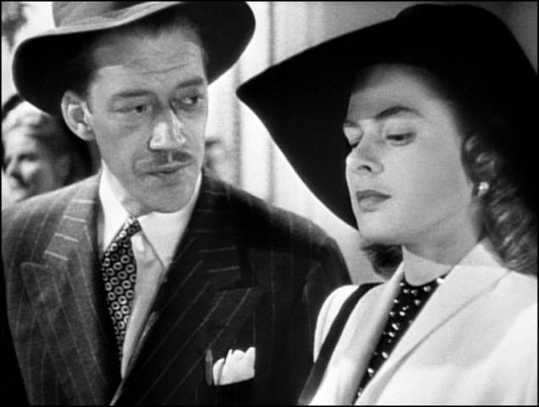

“Perfectly dreadful party”- Outside a beach-side bungalow, a man paces. The scene fades into the darkness of night, but inside the house, the lights burn bright. A record player blares loud dance music as two drunken party goers two-step clumsily. Miss Huberman walks past them with a bottle of liquor in her hand. They talk about the police following her home while she pours drinks for the guests who are still awake. “I’m a marked woman,” she jokes. “I’m liable to blow up the Panama Canal any minute now.” Miss Huberman notes that one of the people is a stranger to her, a man she finds quite attractive, telling him that she likes party crashers. An elderly man says she won’t have to worry about the police for long because they set sail in the morning. Miss Huberman jokingly accepts the offer, but the man seems to take her seriously when he leaves. Miss Huberman kicks the rest of the partygoers out, saying, “I'm very sorry you all have to go. It has been a perfectly hideous party.” Only the mysterious party crasher remains.
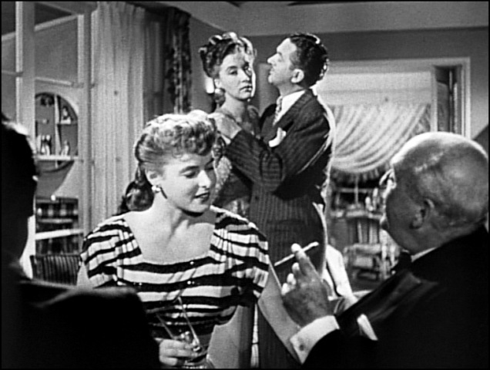
Last drink- “There’s one more drink left apiece,” the party crasher says before lamenting the lack of ice. He asks the grinning Miss Huberman why she enjoys the song she put on and the young woman laughs drunkenly: “Because it's a lot of hooey. There's nothing like a love song to give you a good laugh.” She begins to complain about the temperature of the room, suggesting the two take a picnic. The man humors her somewhat reluctantly, but it’s obvious he wants to be alone with her. Miss Huberman, quite drunk, insists on driving.
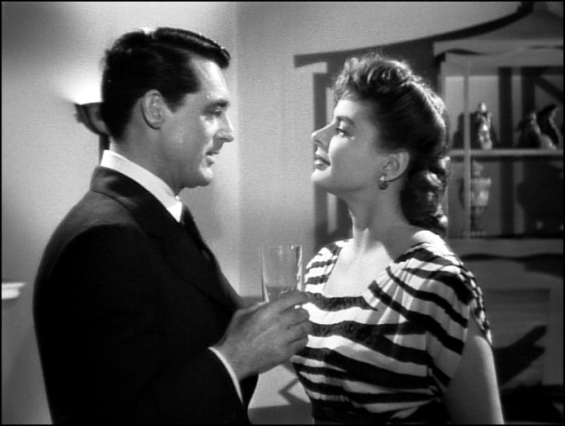

Car ride- A convertible swerves down a palm-lined road through the darkness. Miss Huberman barely maintains control of the car while the party crasher sits nervously in the passenger seat, trying to light a cigarette. “Scared?” Miss Huberman asks. “No,” he replies convincingly. “You’re not scared of anything, are you?” she asks. “Not too much,” he replies, holding his hand near the wheel just in case. Miss Huberman is so drunk she mistakes her hair in her eyes for fog. Unable to read, she asks what the speedometer says, and the party crasher replies, “Sixty-five.” “I want to make it 80 and wipe that grin off your face,” she replies, stepping on the gas.

2nd offense- As the speeding car swerves down the road, a policeman on a motorcycle takes notice. “A cop,” the party crasher says. Miss Huberman doesn’t seem to notice. “A policeman is chasing us,” he enunciates when the whine of the siren grows closer. “Drunken driving,” Miss Huberman says almost proudly, “My second offense.” The car rolls to a stop and the policeman dismounts to confront Miss Huberman. “Havin' a time to yourself, aren't you?” asks the cop. “People like you ought to be in bed,” Miss Huberman retorts. Seeing the situation escalating, the party crasher leans across Miss Huberman, extending his wallet for the policeman to see. The cop is shocked and apologizes, asking the party crasher if he can handle the situation before saluting and driving off. It doesn’t take long for Miss Huberman to figure out that her mysterious guess is a high-ranking law enforcement officer. “What… was your name?” Miss Huberman croaks. “Devlin,” comes his reply. “You double-crossing buzzard!” Miss Huberman shouts. “You’re a cop!” In the ensuing struggle, Devlin knocks Miss Huberman unconscious before driving her car back home.
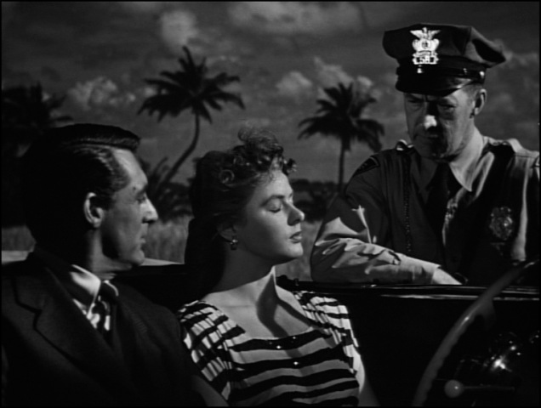

Hangover- Miss Huberman awakes to a glass in front of her face. “You’d better drink that,” says Devlin The camera spins as he crosses the room, standing above her on the couch. After further urging, the young woman sits up and drinks some of the hangover cure. “What’s your angle?” Miss Huberman asks eventually. Devlin claims he only wants to be friends. The young woman doesn’t buy it. “I’ve got a job for you,” Devlin says. “Go away,” she says. “You bore me.” “Some of the German gentry who were paying your father are working in Rio,” Devlin continues before asking, “Ever hear of the I.G. Farben Industries?” He details the plan, saying that since she’s known to some of these men it would be easy for her to infiltrate the group and inform on their activities.
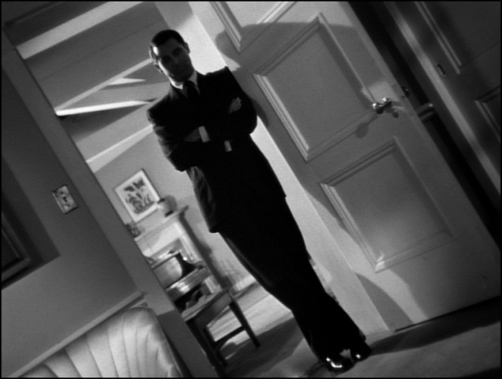
Evidence- Miss Huberman demands to know why she should take the job. “Patriotism,” Devlin says. “No, thank you,” says the young woman. “I don't go for patriotism or — or patriots.” “I’d like to dispute that,” Devlin says, crossing the room to the record player. “We've had your bungalow wired for three months,” he says, placing a record on the turntable. Miss Huberman hears an argument she had with her father: “I hate you all. And I love this country. Do you understand that? I love it. I'll see you all hanged before I'll raise a finger against it.” Reluctantly, Alicia accepts the job when the elderly caller from the night before appears to whisk her away.
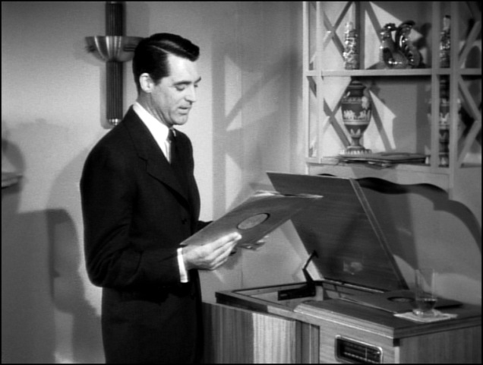

Plane to Brazil- A shot of the Brazilian coastline is followed by a midair shot of a Pan American Airways plane. Inside, Alicia looks out the window while Devlin talks to a man several seats behind them. He returns to his seat beside Alicia and tells her she’ll meet the man in Rio; Paul Prescott, their boss. There are no details about the job yet, but Devlin has some bad news. Alicia’s father died in prison, a suicide by cyanide capsule. Alicia talks about her complicated feelings surrounding the death of her Nazi father. “We’re coming into Rio,” Devlin says. The two look out the window in time to see the famous Christ the Redeemer statue pass below them.

Changed woman- Jaunty samba music plays while the camera jumps from building to building in Rio before landing on Devlin and Alicia seated outside a cafe. Alicia lists her housing requirements, mentioning she needs a maid for cooking, a task she hates. “And find out when I go to work,” she says to Devlin, pointing a finger at him before sipping her drink. When Devlin asks expectantly if she’d like another, she declines. “I’m practically on the wagon!” she jokes. “It’s a phase,” Devlin says. “You don’t think a woman can change?” Alicia asks. “You’ve been sober for eight days,” Devlin replies. “As far as I know, you’ve made no new conquests.” “Why don't you give that copper's brain of yours a rest?” Alicia teases. “Every time you look at me, I can see it dwelling over its slogans: "Once a crook, always a crook. Once a tramp, always a tramp." She continues teasing Devlin, noting his discomfort about his attraction to her.
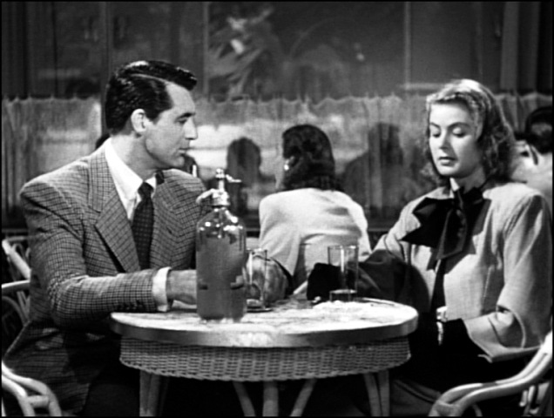

Mountaintop stroll- On a mountaintop above Rio, Devlin and Alicia stop to look down on the urban sprawl and adjacent peaks. Alicia continues her teasing: “You're sore because you've fallen for a little drunk you tailed in Miami, and you don't like it. Makes you sick all over, doesn't it?” She berates him more harshly, and he looks away. The music swells as Devlin takes Alicia in his arms and presses his lips to hers.
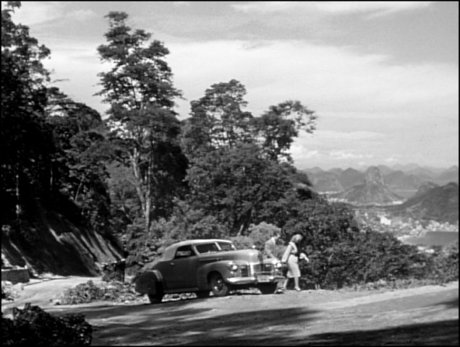
Police meeting- Inside a government building in the city, an American man speaks: “Gentlemen, I assure you she's a perfect type for the job.” A Brazilian lawman speaks up: “It's not the girl. It's this German scientist I'm worried about. I simply question why we don't find some way of taking them into custody.” The American, named Prescott, outlines the plan, how a woman on the inside will allow them to prosecute the Nazi industrialists more effectively. Somewhat reluctantly, the Brazilian authorities agree to sit on their hands and allow the Americans to put their plan in motion. “I'll give Devlin his instructions right away,” says the American who led the meeting.
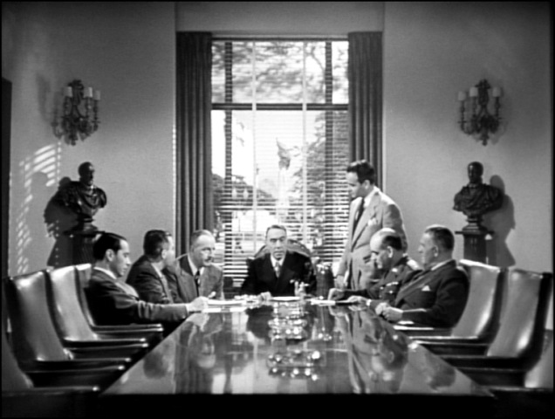

Seaside apartment- A car drives along a row of beachfront apartment complexes, pulling to a stop in front of one. Alicia and Devlin get out and enter the building. In Alicia’s apartment, both step onto the balcony to admire the view. Alicia pulls Devlin into another deep kiss. “It’s nice out here,” she says. “Let’s not go out for dinner.” She offers to cook. “I thought you don’t like to cook,” Devlin replies between kisses. Alicia wants to make him a chicken dinner despite her distaste for the culinary arts. The camera follows behind the two when they cross into the room and over to the telephone. Devlin calls his hotel and listens to his messages. “Prescott wants me over right away,” Devlin reports. Alicia is unwilling to let him go, kissing him over and over, but eventually, they part.

Job description- Devlin pulls up to the government building, a bottle of champagne in his hand. The camera focuses on the bottle sitting on a desk when Devlin’s hand comes down, thumping the table in anger. “I don’t know if she’ll do it!” he exclaims, standing up. “You haven't discussed it with her, have you?” Prescott asks, and Devlin admits he hadn’t considered Alicia seducing the Nazi industrialist until just now. Despite Devlin’s misgivings, his boss gives him and Alicia their assignments. He returns to Alicia’s apartment with a heavy heart, forgetting the champagne.
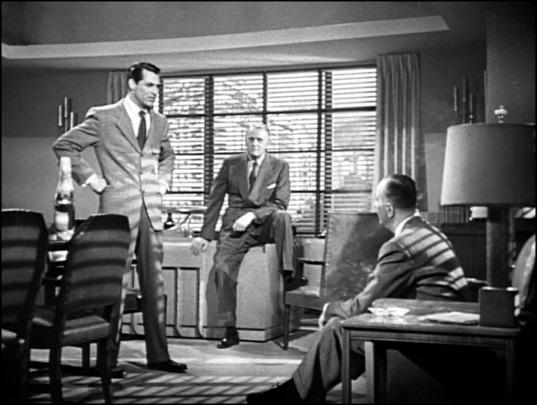

Below the belt- “Dev?” Alicia shouts from the kitchen. “Is that you?” Devlin says it’s him, and Alicia continues to struggle with the chicken in the kitchen, joking that “it caught fire once.” Alicia finishes in the kitchen and meets Devlin on the balcony. He’s somewhat cold in the face of her affection. “Well, handsome, I think you'd better tell mama what's going on,” Alicia says and smiles. “After dinner,” Devlin replies. Alicia presses him, teasing him about being in love and wanting to marry him. “I'll bet you've heard that line often enough,” Devlin spits, an insult meant to accuse her of promiscuity. Devlin outlines the plan to infiltrate the home of Alex Sebastian. Alicia will try and seduce her father’s old friend, something that should be easy given that he was once in love with her. Anything she learns she’ll report to Devlin. After some dramatic back and forth about Alicia being in love with Devlin, she agrees to do the job. Devlin then looks for his forgotten champagne.
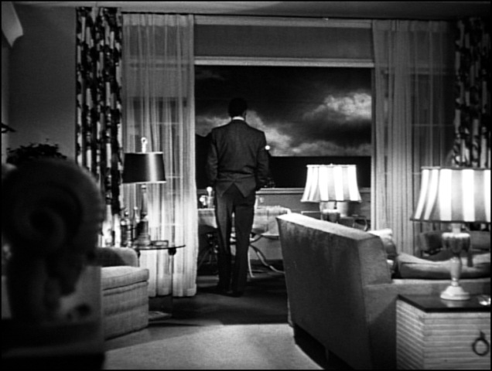
Meeting Sebastian- “In case you’re asked,” Devlin says to Alicia in the back of a speeding car, “I’m with Pan American Airways.” After getting their stories straight, the scene fades to a long, fence-lined path with people on horseback. Devlin and Alicia ride side by side behind another couple. Pulling up alongside, Devlin whispers to Alicia for confirmation about the man’s identity and she assures him that the man is Alexander Sebastian. After failing to get his attention subtly, Devlin kicks Alicia’s horse in the rib, spurring it to sprint away, out of control. Sebastian sees the horse bolt and gives chase to help the woman riding it. He manages to calm down and stop the horse quickly before noticing that it’s Alicia. They greet each other silently in the distance while Devlin watches, a dejected look on his face.


Dinner- Sebastian enters a fancy restaurant, looking around for someone. Alicia sits at a nearby booth, and he crosses the room to join her. “My dear Alicia,” Sebastian says, kissing her hand, “will you forgive me for being late?” Alicia forgives him, and Sebastian admits to some anxiety in meeting her again. He showers her with flirtatious conversation and compliments until Alicia notices Mr. Prescott sitting down at a table behind them. “Do you know him?” Sebastian asks. When Alicia says she doesn’t, Sebastian talks about the ‘infestation’ of American agents in Rio. “I'm allergic to American agents,” Alicia says, smiling. The conversation turns dark when the subject of Alicia’s father comes up. Alicia plays up the act of being ignorant of her father’s activities, and Sebastian seems to buy it. He’s worried about prospects between Devlin and Alicia, but she denies any attraction to him, saying they “just met on the plane.” Sebastian then invites her to a dinner party at his house the next night.
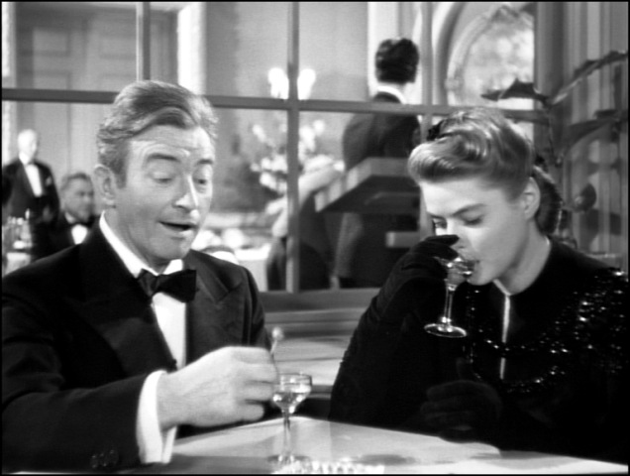
Undercover preparations- Devlin and Prescott stand in Alicia’s apartment. Alicia emerges from her bedroom in a striking gown. Prescott presents her with a diamond necklace rented for the occasion and helps her to put it on. Devlin looks disinterested, focusing on a newspaper. Prescott then gives her instructions: Alicia is to memorize the names of everyone in attendance at the dinner party. Prescott warns her not to ask any questions or to underestimate the Germans. After a final recommendation that Alicia and Devlin keep their distance for the next few days to avoid tipping off the Germans, Alicia leaves for the dinner party.
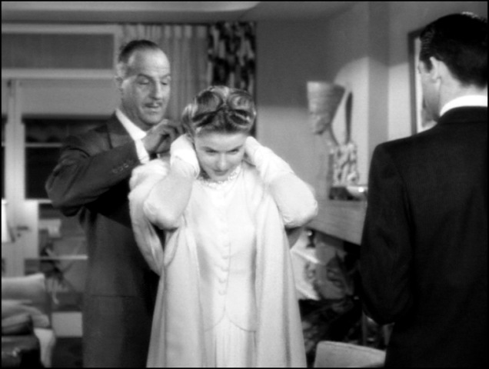

Sebastian’s dinner party- A car stops in front of an opulent manor house. Alicia steps out and walks up the front steps, announcing herself to the butler who opens the door. The butler leads Alicia to a private study before an elderly woman descends the stairs and greets Alicia. She is Madame Sebastian, Alex’s mother. She strikes up a conversation, asking Alicia why she didn’t testify at her father’s trial. “He didn’t want me to,” Alicia replies simply before Alex enters the room, a warm smile on his face. Madame Sebastian continues her cold behavior towards Alicia, interrupting her son to suggest they join the other guests, not even taking her coat. In a parlor, Alicia is introduced to all of Sebastian’s co-conspirators one by one. She seems to absorb their names and faces like a sponge but never lets on that she’s doing so. They move to the dining room where one of the conspirators has a strange reaction to a nearby bottle of wine. The conspirators push him to his seat, trying to cover for his behaviour, though we are not aware of its significance.
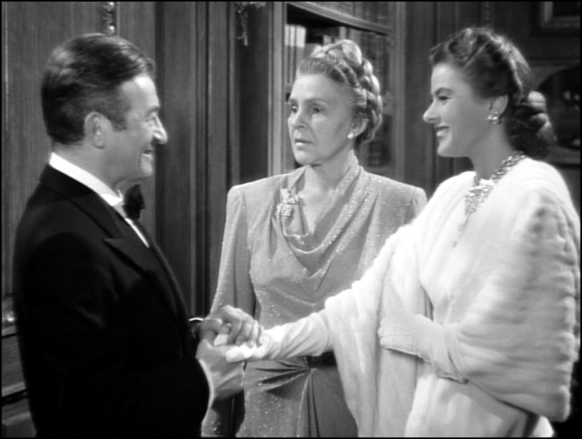
Secret Meeting- The man who reacted to the bottle paces outside the parlor door. Inside, the rest of the conspirators gather around a table, drinking aperitifs and discussing the man’s fate. “Something must be done,” one of them says. “It was an understandable slip,” says another. “A very dangerous slip,” another rebuts. “There have been several other lapses before.” Eric Mathis says that he will “take care of it” after requesting a ride from the offending man. The offending man enters the room, profusely apologizing for his behaviour. After assuring him that it’s not a problem and the group values his health, Eric insists on driving the offending man home. They leave together, the offending man’s face pale and frightened: He knows what is coming.
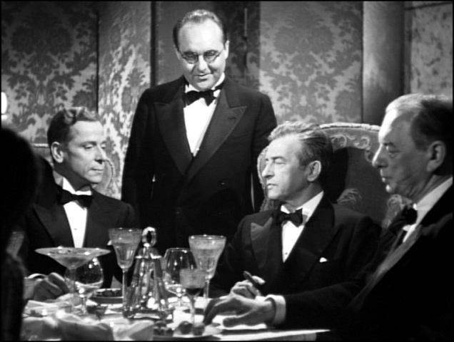

Racetrack- Christ the Redeemer overlooks a bustling racetrack where Sebastian and his mother sit. “Miss Huberman has been gone a long time,” Madame Sebastian comments. Alex chides his mother for acting so coldly toward the woman he loves, asking her to call Alicia by her first name and smile at her from time to time. She doesn’t seem to care, turning her attention back to her newspaper. Devlin walks among the crowd below, looking around for someone. “Hello!” he says, beaming when he sees Alicia. After greeting, their smiles fade and they face forward, leaning on the railing. “Where are they?” Devlin asks, and Alicia begins telling him everything she knows starting with the people who attended the dinner party. She talks about the man’s reaction to the wine bottle and his disappearance.
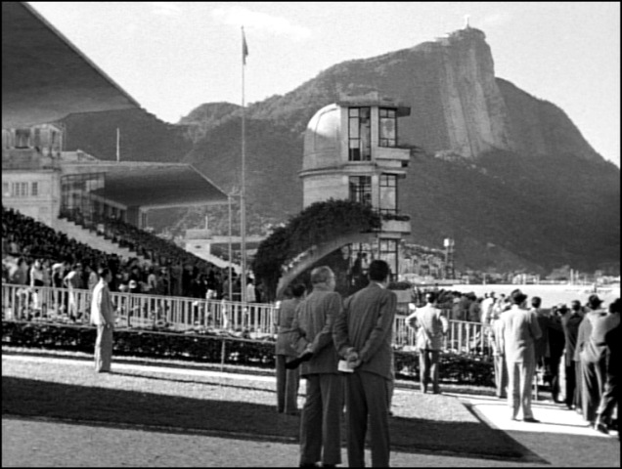
Alicia’s admission- “You can add Sebastian’s name to my list of playmates,” Alicia says as she finishes her report. Devlin looks conflicted, “Fast work.” “That’s what you wanted, isn’t it?” Alicia snaps quietly. “Skip it,” Devlin says. Alicia tries to change the conversation, but Devlin is the one who can’t let it go. He remembers her comments about being a ‘changed woman’ and begins berating her, saying, “It wouldn't have been pretty if I'd believed in you. If I'd figured: "She'd never be able to go through with this. She's been made over by love." Alicia says she hates him. “There’s no occasion to. You’re doing good work,” Devlin replies while tears drip from Alicia’s eyes. She clears her eyes when Devlin spots Sebastian approach. Devlin excuses himself and Sebastian confronts Alicia. He has watched the conversation through his binoculars and believes Alicia is in love with Devlin. Sebastian asks Alicia to convince him Devlin doesn’t mean anything to her.
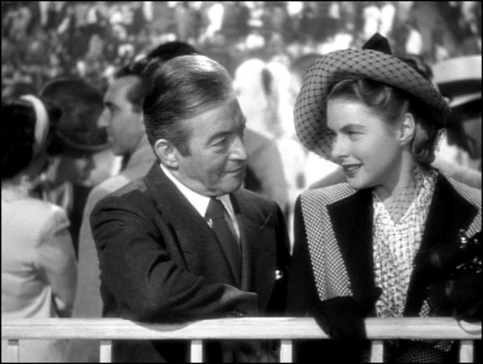

“A woman of that sort”- Inside the government building in Rio, Prescott and Devlin meet with the Brazilian politician, reporting about one of the Nazi conspirators working in Sebastian’s home. Another Brazilian man interrupts them, saying that Alicia is waiting to meet with Prescott or Devlin. “I don't like this. I don't like her coming here,” says one of the Americans in the room. “She's had me worried for some time,” says another man. “A woman of that sort.” Devlin is offended and defends Alicia with some searing sarcasm about the man’s wife. Alicia enters the room with a perplexing problem: “Mr. Sebastian has asked me to marry him.” Prescott asks Alicia if she’s willing to go that far, and she says she is. They advise her to go through with the marriage.
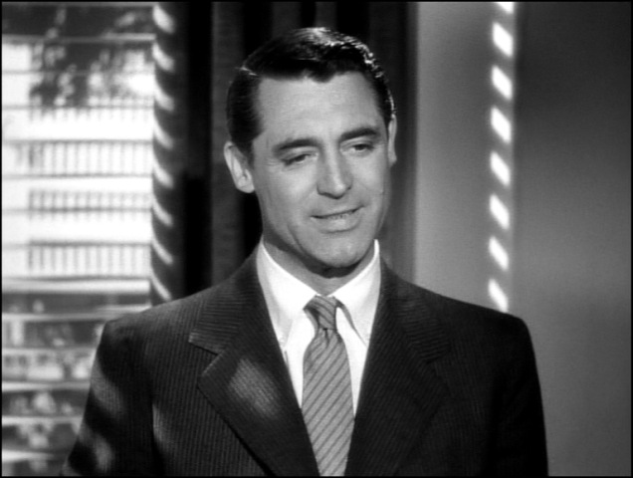
A mother’s jealousy- Alex’s mother works on some needlepoint in her bedroom. “Are you quite sure she didn't come down here to see you?” Madame Sebastian asks her son, her foul mood bleeding into her words. “To capture the rich Alex Sebastian for a husband?” They argue for a moment about Alicia before Alex says, “These carping questions are merely the expression of your own jealousy, just as you've always been jealous of any woman I've ever shown any interest in.” Madame Sebastian incredulously asks if he means to go through with the marriage, and Alex responds they will have a private ceremony the following week. “We shall both be pleased to have you present, if you wish,” he says before leaving the room.
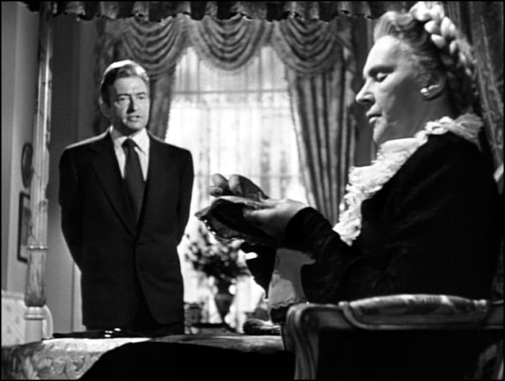

Moving in- A car pulls to a stop in front of Sebastian’s manor under shimmering moonlight. Sebastian and Alicia exit the car and quickly head inside while the driver unloads their luggage from the car’s trunk. Joseph, the butler answers the door. “It doesn’t look very cheery in here,” Sebastian complains, and Joseph explains that Madame Sebastian ordered the house staff to retire, although they had received news of the new couple’s return via telegram. Despite the obvious slight, Alicia appears unbothered, smiling at her husband. The scene fades while Sebastian leads his bride upstairs. The next morning, Alicia orders the servants around gently as they help to unpack her trunks bursting with belongings. In a search for storage space, Alicia finds that one closet is locked and that Madame Sebastian has the key.
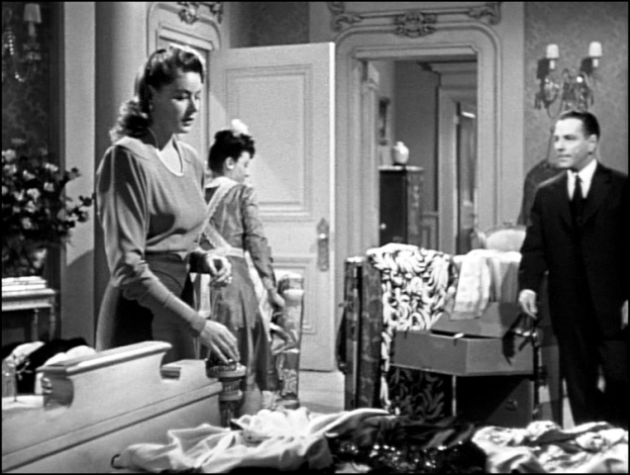
Report interrupted- In the study downstairs, Sebastian and his co-conspirators gather to discuss their plans. One of the men paces, lamenting the loss of the man who reacted to the wine bottle, saying, “He was a first-class metallurgist.” Another man says the replacement is “just as good,” but the first man doesn’t agree. Instead of arguing, he turns the conversation back to a report from the lab. He begins speaking, but the clandestine meeting is interrupted by Alicia asking after the keys. Sebastian leads her away and up the stairs with a simile, seeking out his mother for her key ring. Madame Sebastian shouts something, but the door muffles the argument between mother and son. Sebastian emerges with a smile and a ring of keys for Alicia.
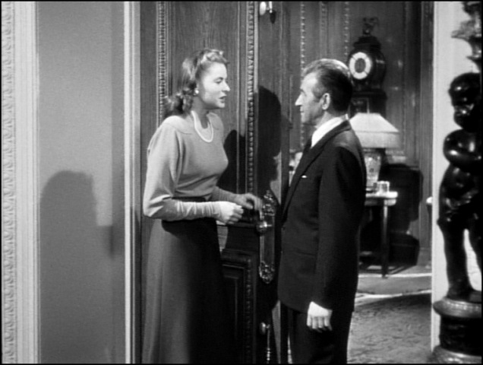

Closets and keys- Door after door opens while Alicia familiarizes herself with the nooks and crannies of the house. Joseph leads her from closet to closet, seeking a place to store her fur coat. One door is still locked to her. The deadbolt reads ‘U’nica,’ and Mr. Sebastian is the one who holds the key. Sometime later, Alicia and Devlin sit on a bench in a park. “Well, then the wine cellar is the obvious place to look,” Devlin says, urging Alicia to find the key. She’s not sure what they’ll do when she gets into the cellar. “You look for a bottle of wine, like the one that rattled the fellow at dinner that night,” Devlin explains. He then tells her to convince Sebastian to throw “a large shindig” to introduce his wife to his friends, including Devlin.
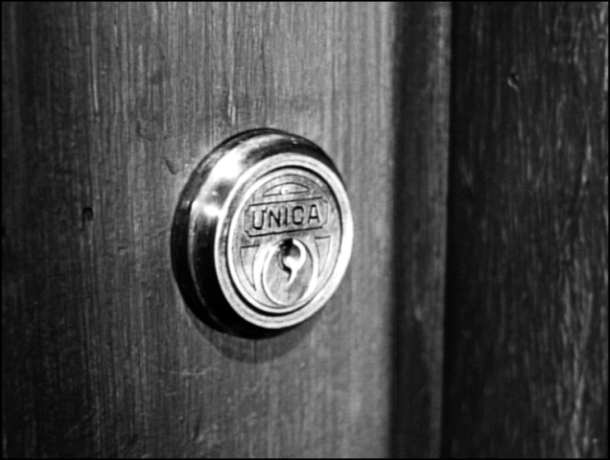
The key- Sometime later, Alicia is preparing for the big event with Sebastian. As she puts her earrings on, she notices Sebastian’s key ring on a nearby vanity table. Creeping closer, she can see Sebastian’s shadow in the nearby bathroom. He begins passive-aggressively complaining about Devlin’s presence at the party while Alicia silently sifts through the keys, finding the one labeled ‘U’nica.’ She pulls it from the ring and palms it in her hand. Sebastian emerges from the bathroom suddenly, taking Alicia’s hands in his. He apologizes for his suspicions and pulls Alicia into an embrace. Alicia manages to keep the key hidden, passing it from hand to hand behind Sebastian’s back, dropping it, and kicking it under a nearby table.
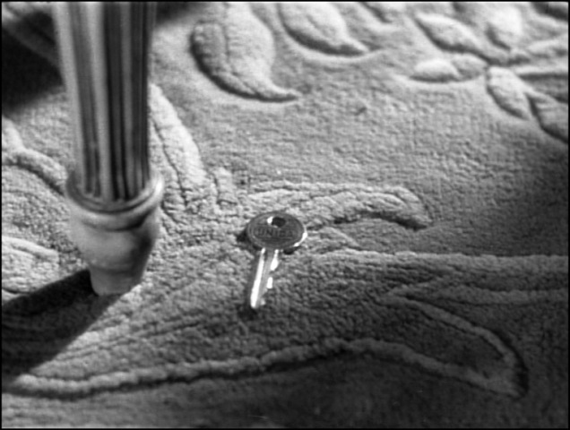

Shindig- The camera looks down at the great foyer of Sebastian’s mansion, filled with people in fancy dress clothes talking excitedly to one another. The shot tightens and we recognize the figures of Sebastian and Alicia standing among the party-goers. The shot focuses on Alicia’s hand,which twitches nervously, tossing the cellar key in her palm. Sebastian and Alicia part and join the guests when Devlin enters. He makes a beeline for Alicia while Sebastian watches from afar. When Devlin kisses Alicia’s hand, she slips the cellar key to him. After the usual greeting and some play-acting, Devlin gets serious. He sees Sebastian watching them. “This isn’t going to be easy,” Devlin says. Alicia asks Joseph if they’ll have enough champagne to last the evening, realizing they only have a short time to enter the wine cellar undetected. She tells Devlin to go alone into the garden and she’ll show him the way to the wine cellar after losing Sebastian. Seeing Devlin wander into the garden alone seems to calm Sebastian, and Alicia waits for an opportunity to part from him. She makes up an excuse, saying she’s going to ask the conductor to play different music, and quickly makes her way to the hallway outside the wine cellar.
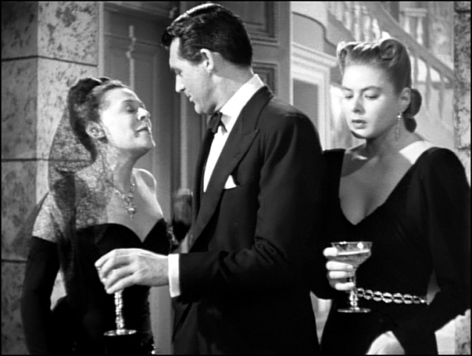
Wine Cellar- Devlin paces outside the garden door when Alicia appears on the other side, letting him in and showing him the wine cellar. Inside is a stone basin surrounded by racks upon racks of dusty wine bottles. Alicia keeps watch by the garden door until she hears a crash from inside the cellar: While snooping Devlin has knocked over a bottle of wine, but inside isn’t an aged vintage. Instead, it’s black sand. With Alicia’s help, Devlin scoops up a sample and cleans up the evidence of the breakage. Upstairs, Joseph sees the bottles of champagne dwindling and seeks out Mr. Sebastian. They head downstairs together. “Someone’s coming,” Alicia whispers when she and Devlin step outside. “It’s Alex. He’s seen us.” Devlin pulls Alicia close as she tries to run away: “Wait a minute. I'm going to kiss you.” Alicia replies, “No, he'd only think we'd…” “That's what I want him to think,” Devlin interrupts before he presses his lips to Alicia's. Sebastian sees the kiss through the door’s window and rushes outside to confront them.
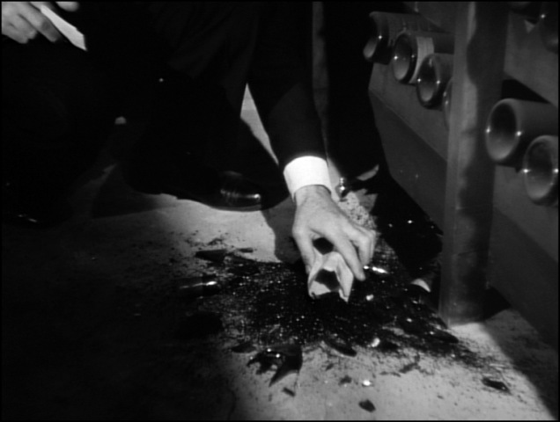

A husband’s rage- “Push me away,” Devlin whispers to Alicia when Sebastian approaches. “I’m sorry to intrude on this tender scene,” Sebastian says, his anger barely contained. “I couldn’t help what happened,” says Alicia. “He’s been drinking.” Sebastian doesn’t buy it: “You love him.” Devlin says, “For what it's worth, as an apology, your wife is telling the truth. I knew her before you, loved her before you. But I wasn't as lucky as you.” After he leaves, Sebastian angrily tells his wife to attend to her guests, saying they’ll discuss the situation later. Upstairs, Devlin puts on his coat. “Mr. Devlin,” Madame Sebastian says as she walks down the stairs, “are you going so soon?” Devlin explains that he has to be up early before exiting the home.
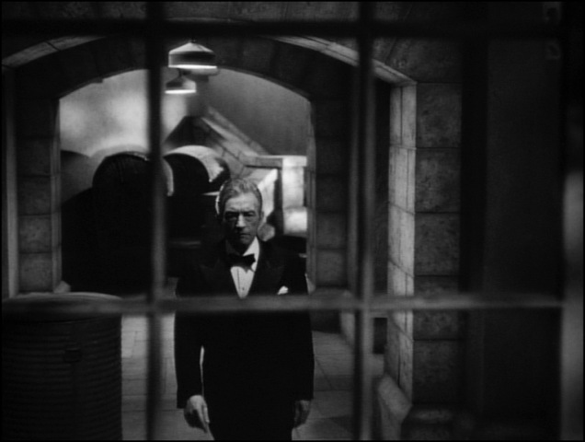
Alicia’s apology- “Joseph,” Sebastian says to his butler, “I’m going down for the wine now.” The butler follows him back downstairs to the wine cellar. Pulling out his key ring, Sebastian notices a key missing. He looks up at the wine cellar door, his mind working while his eyes move. “You know, Joseph,” Sebastian says to his butler, “I don't think we need to give them any more champagne.” They return upstairs, discussing what other libations they could offer the guests. After the party, Alicia and the Sebastians wave farewell to the last of their guests. Only they and the servants remain in the foyer. Madame Sebastian retires upstairs, leaving Alex to speak with his wife. Alicia begins apologizing for Devlin’s advances in the garden when Sebastian cracks a grin. Taking her hand, he says, “My dear, I shall never forgive myself for behaving like a stupid schoolboy.” He promises never to mention it again and bids her goodnight, saying Dr. Anderson awaits him in the study. Alicia ascends the stairs and the smile drops from Sebastian’s face.
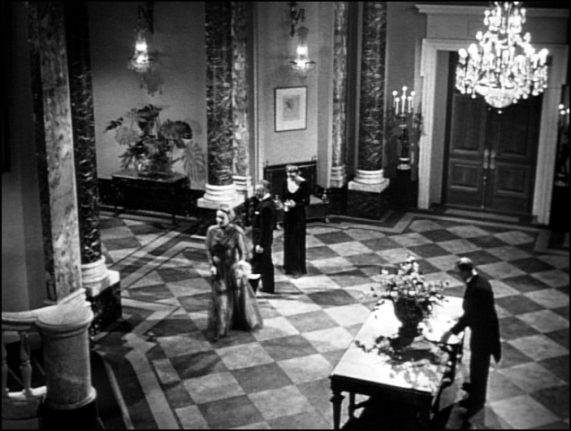

Key ring- Later, upon entering the bedroom, Sebastian looks over at Alicia asleep in her bed, and drops his key ring on the vanity table. The sun rises the next morning, and Sebastian lies awake in bed. He stands, puta on his robe and walks to the table. Sebastian looks down and sees the U’nica key attached to the others. He hurries down to the wine cellar to investigate further. He doesn’t notice anything out of the ordinary and looks around, confused. His eyes land on a wine stain in the stone basin, and he moves back to the special vintage. Looking at each bottle, he finds that one is the wrong vintage: 1940. He tips the bottle up, noting a small amount of its contents are missing and the bottle lacks a cork. He sees sand on the floor and discovers the broken bits of bottle kicked under the shelf.
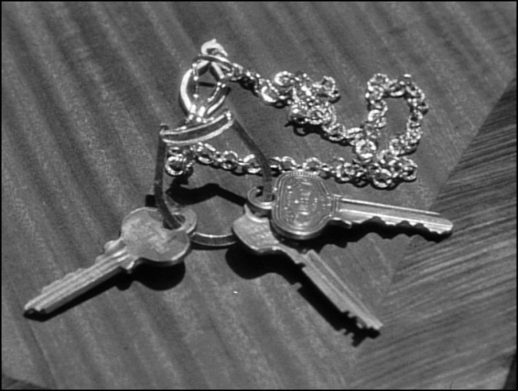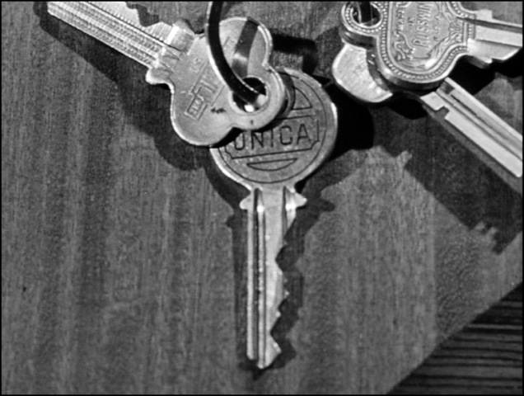
Mother’s advice- Sebastian climbs the stairs with a frightened look on his face as dramatic music plays. The scene fades out to reveal Sebastian seated in his mother’s bedroom. He calls to her gently, coaxing her from her sleep. “Why are you up so early?” she asks. “I need your help,” says her son before explaining his discovery and his suspicions about Alicia. Madame Sebastian is delighted to hear the news, having suspected Alicia the whole time. She lights a cigarette thoughtfully as the scene fades to Alicia asleep in bed. The camera returns to Madame Sebastian, who has quickly concocted a plan to deal with the traitor. Alex is afraid his co-conspirators will discover his mistake and kill him like they did Emil. His mother promises to ‘clean up the mess’ quietly so the others don’t discover anything.
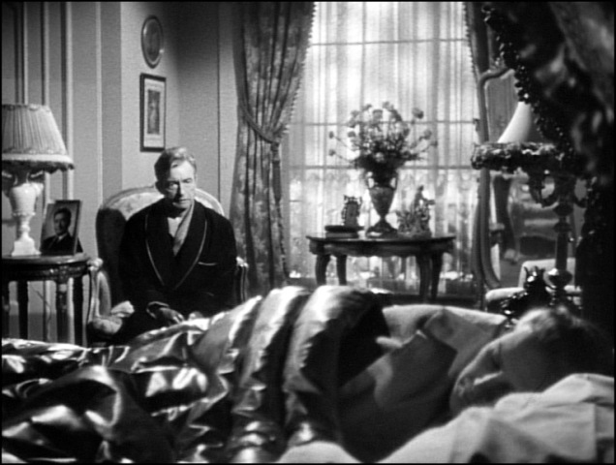

Uranium- Sebastian sits in the garden talking to Alicia. He prepares a cigar, asking his wife what she plans to do with her day. “I just have a little shopping,” she replies while the camera pans down the table, resting on her cup of coffee. She takes a drink and the camera pans to rest on Madame Sebastian and her needlework. In Prescott’s office, Alicia complains of a headache, and Prescott closes the blinds for her. “Some people get too much sun down here,” he says before getting down to business. “That sand that Devlin brought in shows uranium ore. So, now we know what we're driving at. And your job from now on will be to try to help us find out where that sand comes from.” He then informs her that Devlin’s been transferred to Spain. Alicia is conflicted by the news. When she returns home, Sebastian and Joseph have to help her inside when she nearly faints.
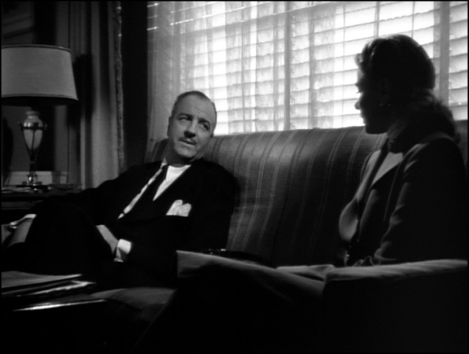
Nothing new- Devlin and Alicia meet in a park for the last time. “What’s new?” Devlin asks. “Nothing,” Alicia replies, staring daggers at the man. The conversation becomes lighter and the heat seems to dissipate from Alicia’s expression. “You don’t look so hot,” Devlin comments, concerned. She blames a hangover for her condition. Devlin makes light of it, implying she’s a lush. After a bit more conversation, Alicia returns the scarf Devlin gave her in Miami. When she moves to leave, Devlin asks where she’s going. “Back... home,” she replies, briskly walking away to hide the tears in her eyes.
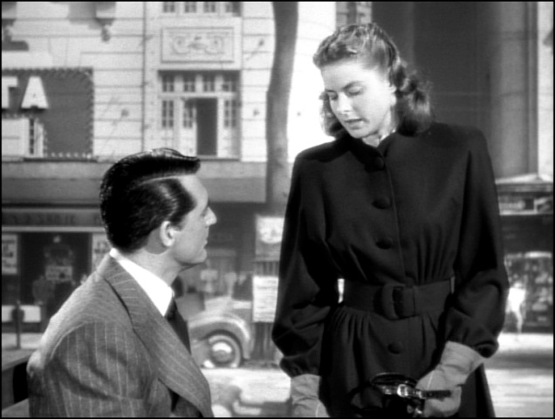

Coffee- “You are not taking care of yourself, Alicia,” says Sebastian. Dr. Anderson tends to her while Madame Sebastian sits on the loveseat opposite Alicia. She pours a cup of coffee and the camera zooms in, following the cup’s course across the room to Alicia’s side table where it joins another. “When did you first feel sick?” Sebastian asks as the camera rests on Alicia’s face. “I don’t know,” she replies, guessing it was after the party. Her husband suggests a sea voyage rather than the hospital, telling her a trip to Spain would do her wonders. Alicia says the sea always makes her sick. Dr. Anderson suggests that she should accompany him on his trip to the mountains, but Sebastian thinks it’s a bad idea. Alicia drinks her coffee and places it on the side table. When Dr. Anderson reaches for his coffee, he accidentally grabs Alicia’s, causing Sebastian and his mother to panic. Alicia puts two and two together as the room starts spinning. Later, she collapses trying to climb the stairs. The others whisk her upstairs and place her on her bed.
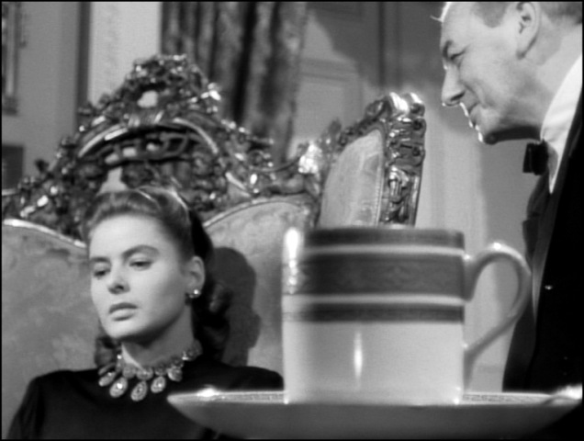
Five days- Devlin sits on a park bench, fidgeting impatiently. The scene fades to Alicia in bed, Madame Sebastian working on her needlepoint nearby. Now dark, the camera finds Devlin again. He paces in front of the park bench. The scene fades again, into Prescott laying on a bed in his tiny apartment. Devlin stands above him, a worried look on his face. “Five days,” Prescott says, spreading butter on a cracker. “Say, that must be quite a binge she's on.” Devlin says he doesn’t believe she was drunk. Alicia was acting strangely and he’s quite intimate with how she acts when drunk. Devlin says he plans to call on Alicia. “Now, wait a minute,” says Prescott. “I don't want you to mess things up.” “I won't mess anything up,” Devlin promises. “It’s just a social call. I'm a friend of the family.” Prescott gives him the okay, asking for a report as soon as he returns.
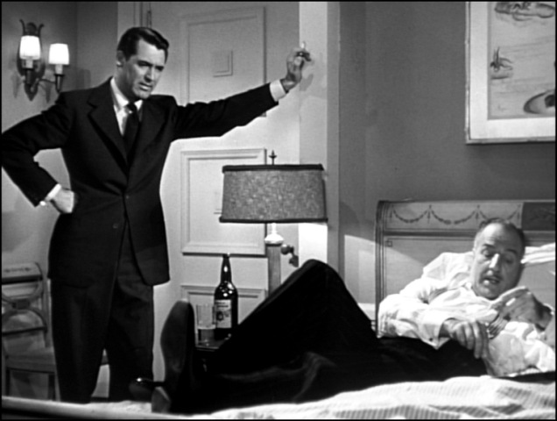

Social call- Devlin parks his car in front of Sebastian’s mansion, then approaches the front door. Joseph answers, somewhat nervously telling Devlin that Mr. Sebastian is preoccupied with business associates and Alicia is confined to bed because of illness. Devlin asks about Alicia’s illness. “We're all very concerned about her,” Joseph says. The butler walks off to tell Sebastian about Mr. Devlin calling, walking briskly to the study. “Tell him I’ll be with him in a minute,” Sebastian instructs Joseph before returning to his conversation with his co-conspirators. Dr. Anderson says that he was followed by a man who he suspects to be an American agent.
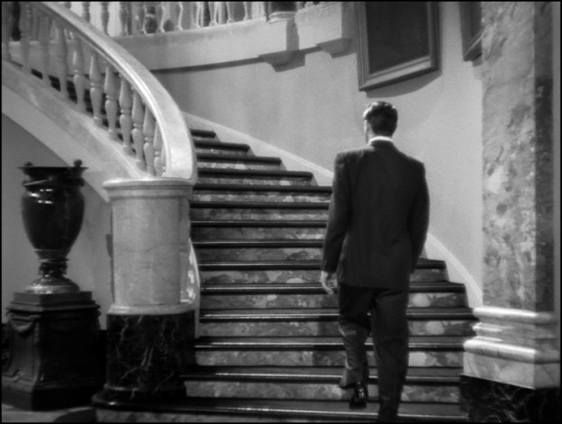
Master bedroom- Waiting in the foyer, Devlin watches Madame Sebastian walk into her bedroom. Seizing the opportunity, he quickly ascends the stairs and enters the master bedroom. He sees Alicia languishing in bed and hurries to her side. “Alicia,” he whispers, holding her hand. “What’s wrong with you?” “I’m so glad you came,” she says weakly.” “I had to,” Devlin replies. “I couldn’t stand it anymore, waiting and worrying about you.” After some persistent questioning, Alicia finally tells Devlin that she’s being poisoned. “I’ve got to get you out of here,” Devlin says as he hoists Alicia into his arms. “I was getting out [of Rio] because I love you,” Devlin confesses. “I couldn’t stand seeing you and him together.” They embrace and kiss before Devlin helps Alicia into several coats. She tells him that only Sebastian and his mother know about her betrayal. The co-conspirators would “kill him if they knew.” Devlin decides to take a risk, helping Alicia leave the bedroom.
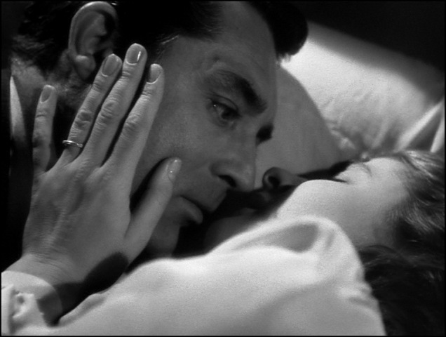

Escape- “You’ll never get rid of me again,” Devlin promises as they reach the top of the stairs. Sebastian appears and demands to know what Devlin is doing. “I'm taking her to the hospital to get the poison out of her,” Devlin responds plainly. “How’d you like your friends downstairs to know?” Madame Sebastian emerges from her room. “He knows?” she asks her son. Dr. Anderson and the other co-conspirators exit the study to see what’s the matter, and Devlin takes his chance to continue down the stairs. He says he’s taking Alicia to the doctor because she’s sick. “You haven't forgotten what they did to Emil, have you, Sebastian?” Devlin whispers. “Help him, Alex,” Madame Sebastian hisses. Sebastian remains silent but joins Devlin in ushering Alicia out of the house.
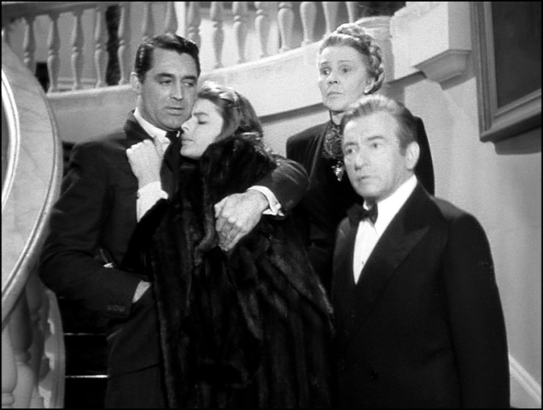
“I wish to talk to you”- With his co-conspirators growing more suspicious with each step Devlin and Alicia take, Sebastian finally speaks up: “Um, sh-she collapsed. Mr. Devlin heard her scream when he was waiting for me.” The co-conspirators don’t seem to buy it, their faces cold. Outside, Alicia says she’s dizzy as Devlin and Sebastian usher her into the car. Just as Sebastian turns to follow them in, Devlin closes and locks the door: “No room, Sebastian.” “You must take me,” Sebastian begs. “They’re watching me.” Devlin starts the car and drives off. “There’s no telephone in her room to call the hospital,” one of the conspirators says to the others. “Alex, will you come in, please?” Dr. Anderson asks calmly. “I wish to talk to you.” With a pale face and tight lips, Sebastian turns to face those who were once his comrades. Slowly, he enters the house as dramatic music swells. The door closes, and the screen fades to black.
